Finance - Revision Exercise – Dividends, Capital Structure, Forex, Options

- Explain the following terms

(a) passive residual theory of dividends
- clientele effect
- signalling effects
- ‘bird-in-the-hand’ view

- The decision over how much to payout and how much of earnings to retain is a key decision for managers. Identify and discuss the important factors that management should consider when deciding on the size of dividend to be paid to investors.

- Three old lags from business school meet up to spoil a good walk by playing a round of golf. During the game they discuss the profitable companies they now run. The conversation drifts towards dividend policy…

Boss A says his dividend policy is to pay no dividends at all .
Boss B says that he always pays a dividend of 50% of earnings after tax.
Boss C says that she maintains a low but constant dividend per share, offers scrip dividends, and shareholder perks.

One of the companies is a tech company, one is a utility.

Discuss the advantages and disadvantages of the alternative dividend policies.

Which boss runs the tech company, the utility, and which sector would you think the other company might come from (for the third company - more of a judgement call)? Which type of shareholder would be attracted to these companies?

- What are the agency concerns surrounding the dividend decision?

- Do flotation costs favour high dividends or low dividends – discuss.

- When using debt and equity weights to calculate the wacc, do we use book values or market values, and explain why.

- The majority of high growth companies do not use debt to finance new projects, but some do. Which type of high growth company would be more likely to use debt than equity to finance expansion?

- (a) What are the direct costs of bankruptcy? What are the indirect costs of bankruptcy? Which are more of a burden on companies? Can you illustrate with an example.

(b) How much protection should companies in Chapter 11 Bankruptcy (US) or in Administration (UK) be given to carry on their business? – talk through with an example to back up your argument.

- What are the agency concerns surrounding the capital structure decision? What impact would the following have on the decision; managers are rewarded largely by earning per share growth, managers are rewarded by economic value added created, managers rewarded largely by share options.

- Raeburn plc currently has 10m shares outstanding, with a market price of 500p per share. It also has £20m of 7% debt outstanding, which are trading at par. Raeburn is considering a £40m investment program that it will finance either with (a) all equity sold at 500p per share, or (b) all bonds issued at par with a 9% coupon.

If the project is undertaken, Raeburn believes it can attain £10m per annum in earnings before interest and tax.

The tax rate is 30%.

Calculate the earnings per share for each financing method.
Draw an EBIT-EPS graph for your results.

If the EBIT for the project turned out to be £6m, which form of financing would you recommend?

- Why is the expected bankruptcy cost much larger to the owner of a private company than it is to the shareholders of a stockmarket listed company?

- If a company has too high a level of gearing, how can they quickly reduce their gearing – how easy is this to do?

13. It is argued that debt adds discipline to management. Why?
Which of the following types of companies will most benefit from debt adding this discipline?
a) conservatively financed, privately owned companies
b) conservatively financed, stock market listed companies, with a wide and diverse group of shareholders
c) conservatively financed, stock market listed companies, with an activist and primarily institutional holding

14. Rank the following companies on the magnitude of bankruptcy costs from most to least, taking into account both direct and indirect costs:
a) supermarket company
b) aeroplane manufactures
c) construction company
d) photocopier company

15. Both Reckitt and Pearson have large cash balances, you are a shareholder in both companies. The managers claim to hold the cash because they need flexibility. Which of the two managements are you most likely to accept this from?

Pearson owns the FT, Penguin books, Pearson education. It is heavily involved in multimedia. Over the past years it has owned TV stations, investment banks, a crockery company (Royal Doulton), Madame Tussauds, internet companies. The Pearson share price chart is shown below.

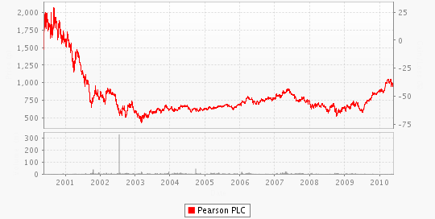

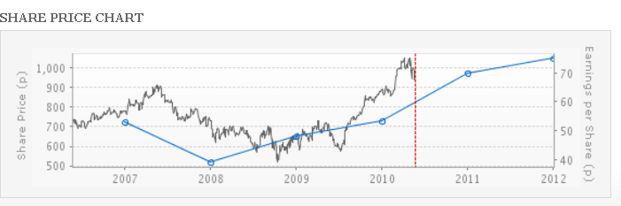

The line with the circles on it represent past and prospective future earnings per share figures, indicated on the right hand axis.

Reckitt Benckiser is an Anglo – Dutch household goods firm, owning brands like Dettol, Nurofen, and Lemsip. Since the merger in 1999, Reckitts have continued to acquire, the latest acquisition being the Boots Healthcare division for nearly £2bn in 2006. The share price chart is shown below.

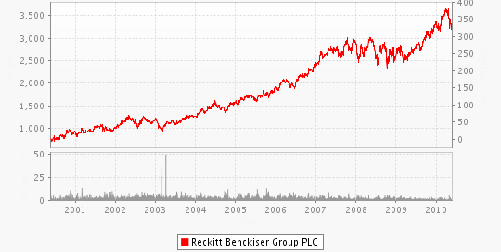

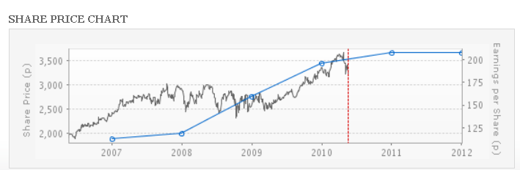

16. In the period 2002 – 2004 companies like BT, Marconi, NTL, Granada, SMG, British Airways, France Telecom, Deutsche Telecom, Vivendi, Scottish Power, Lucent, Nortel, Alcatel, TXU, Invensys, British Energy, Leeds United, Colt Telecom, faced huge debt problems and financial distress. Why was the amount of debt a problem and what were their options to get out of the financial mess?

17. If the interest rate in the UK is 2.5% and in Japan it is 0.5%, and the current spot exchange rate is 128.1 yen to the pound, what is the six-month forward exchange rate?

18. With regard to foreign assets, what should a company hedge?

19. Ford wants to build a car plant in Spain, does it make sense for Ford to raise debt finance in euros (in general, ignoring the current chaos in the currency markets)? Explain your answer.

20 The expected annual inflation rate in Columbia is 10% and in Chile it is 3%. The current spot exchange rate is 3.48 Columbian pesos to a Chilean peso. What is the expected spot rate in one year’s time?

21. The annual interest rate in Switzerland is 2.5%, in Russia it is 9%. The Swiss franc trades at 19.58 roubles on the spot market, what is the 6 month forward exchange rate?

22. If a call option has an exercise price of 700p and the share price is 725p, is the call option ‘in-the-money’ or ‘out-of–the-money’?

23. If a put option has an exercise price of 45p and the share price is 44p, is the put option ‘in-the-money’ or ‘out-of–the-money’?

24. What are the payoff possibilities for a call option seller (writer)? Draw the payoff diagram.

25. If you buy a HSBC June 600 call option for 9.5p today, with the share price at 595p, what will be your profit/loss at expiry if the shares are close at 605p at the expiry of the option series?

26. The current share price of BP is 550p. Over the next year the share price will either go to 750p or 450p, with equal probability. The risk free rate of interest is 4%.

What is the price of a call option using the binomial pricing model, if the exercise price is 500p? What is the put option price?

27. Give examples where you might encounter options in your everyday life.

28. What does it mean when you ‘exercise’ an option?

29. Today you have bought a 750p June put option on WPP for 30p with the current share price at 762p.

  - If WPP’s share price at the end of June is 785p what will your put option be worth, and what is your profit or loss on the position?
  - If the share price closes at 710p at the end of June what is the option value and your profit and loss on the position?

30. Why would you not exercise an option early? When might you exercise early?

31. If you owned a business and needed to borrow £1m in 3 months time and there was considerable uncertainty over the direction of the next moves in interest rates, what would you do?

32. What are the arguments against hedging?

33. Who are most happy for a company to hedge, bankers, shareholders, bondholders, managers? How does a hedge work?

34. The share price is 225p, the exercise price is 200p, the risk free rate of interest is 5%, the volatility is 30% , what are the prices of a one year call option and put option, using the Black-Scholes option pricing method?

35. If the share price is 330p and the exercise price is 350p, the risk free rate of interest 4% and the volatility 40%, what are the six month call and put prices using the Black-Scholes option pricing model?

36. Using the data from Q.35, but changing the volatility to 80%, holding everything else the same, what are the call and put prices using the Black-Scholes model?

37. Using the data from Q.35, but changing the time to 1 year (volatility going back to 40%), what are the call and put prices using Black-Scholes?

38. Using the data from Q.35, but changing the interest rate from 4% to 8% (time is 6 months and volatility is 40%), what are the call and put prices using Black-Scholes?

39. Compiling all the prices from Q.35 to 38 and putting them in a table, what comments would you make on the prices that you have generated?

